Azure Cloud Platform

MY SQL

AZURE SQL

Extract and Load thorough linked services

**Steps to create Pipeline:**

* Create necessary resource – RG, ASQL, ADF
* Create new pipeline in ADF
* Select copy activity and provide the source as on prem, target as AQSL.
* Source data can be accessed through self-integration runtime linked services.
* Install the self-integration runtime if its first time and register the key.
* Target data can be loaded to ASQL using autointegration runtime using Sink option
* Publish and trigger the pipeline.

Points to remember:

Datasets will be created for the source and target when you the above actions. That can be verified.

* Refer the following screenshots which gives all the details of above-mentioned steps.

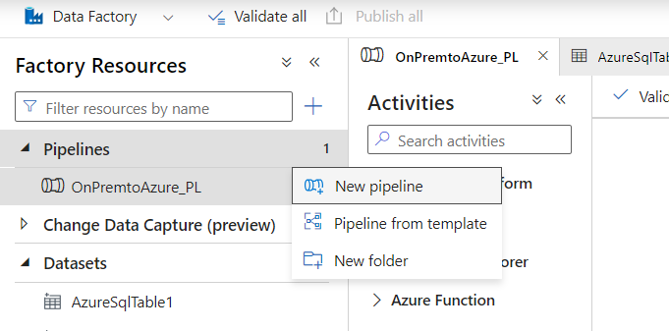

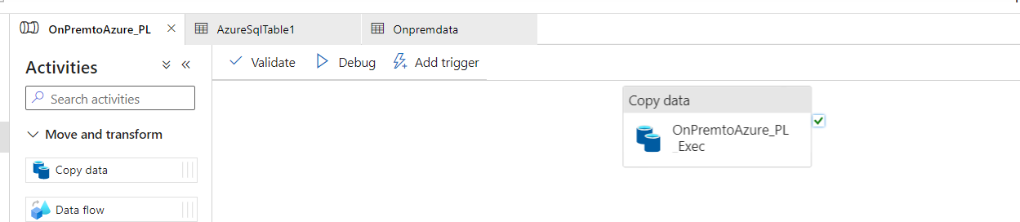

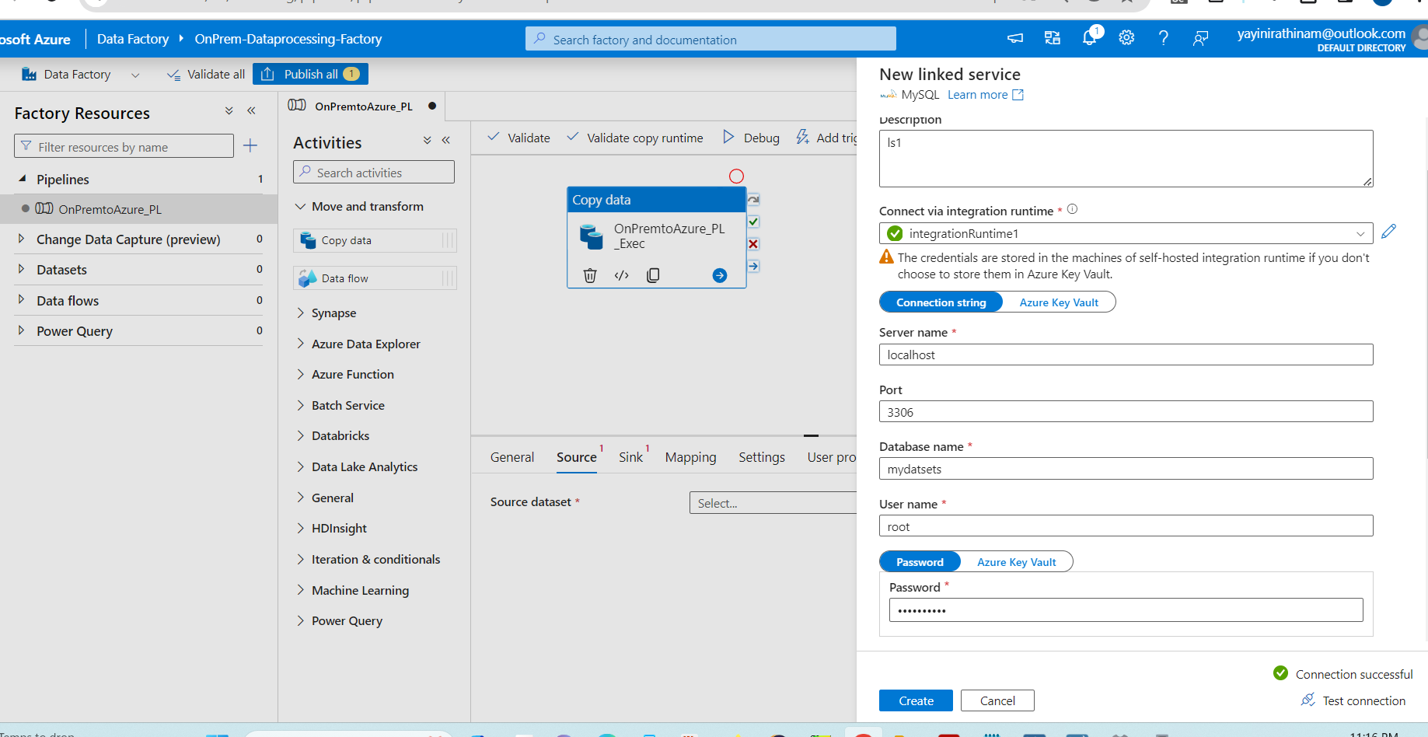

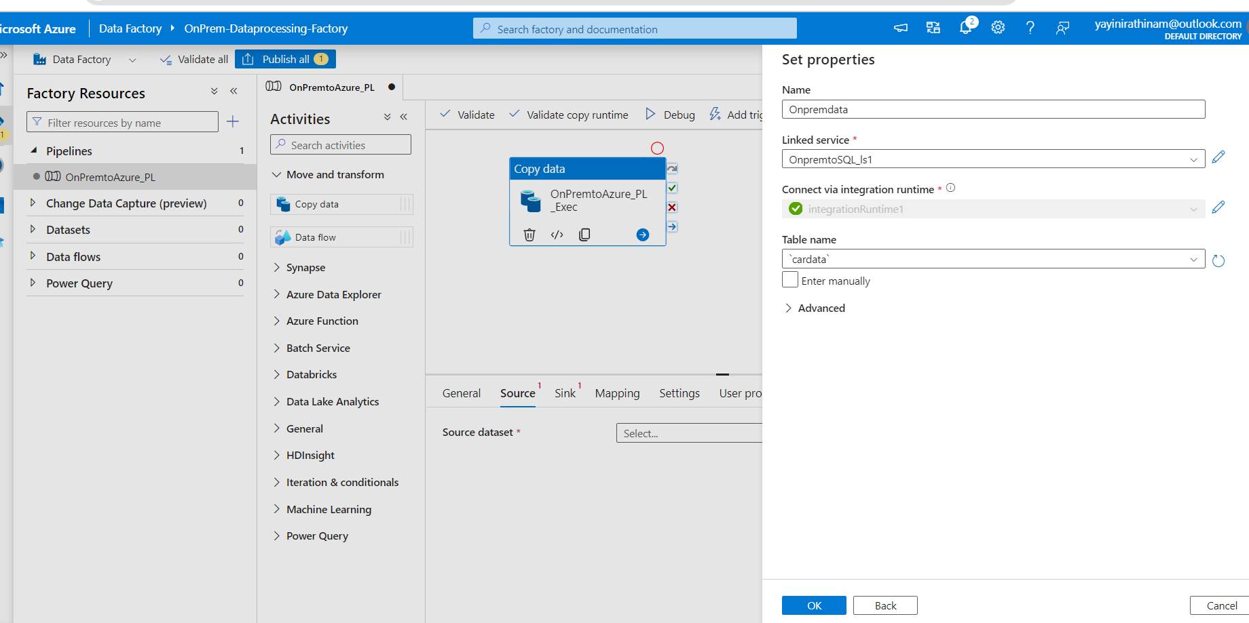

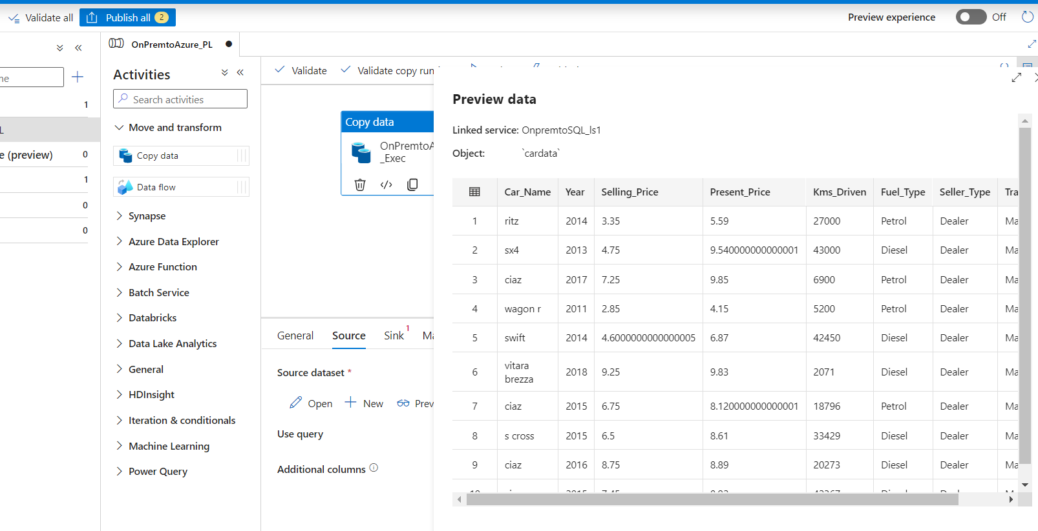

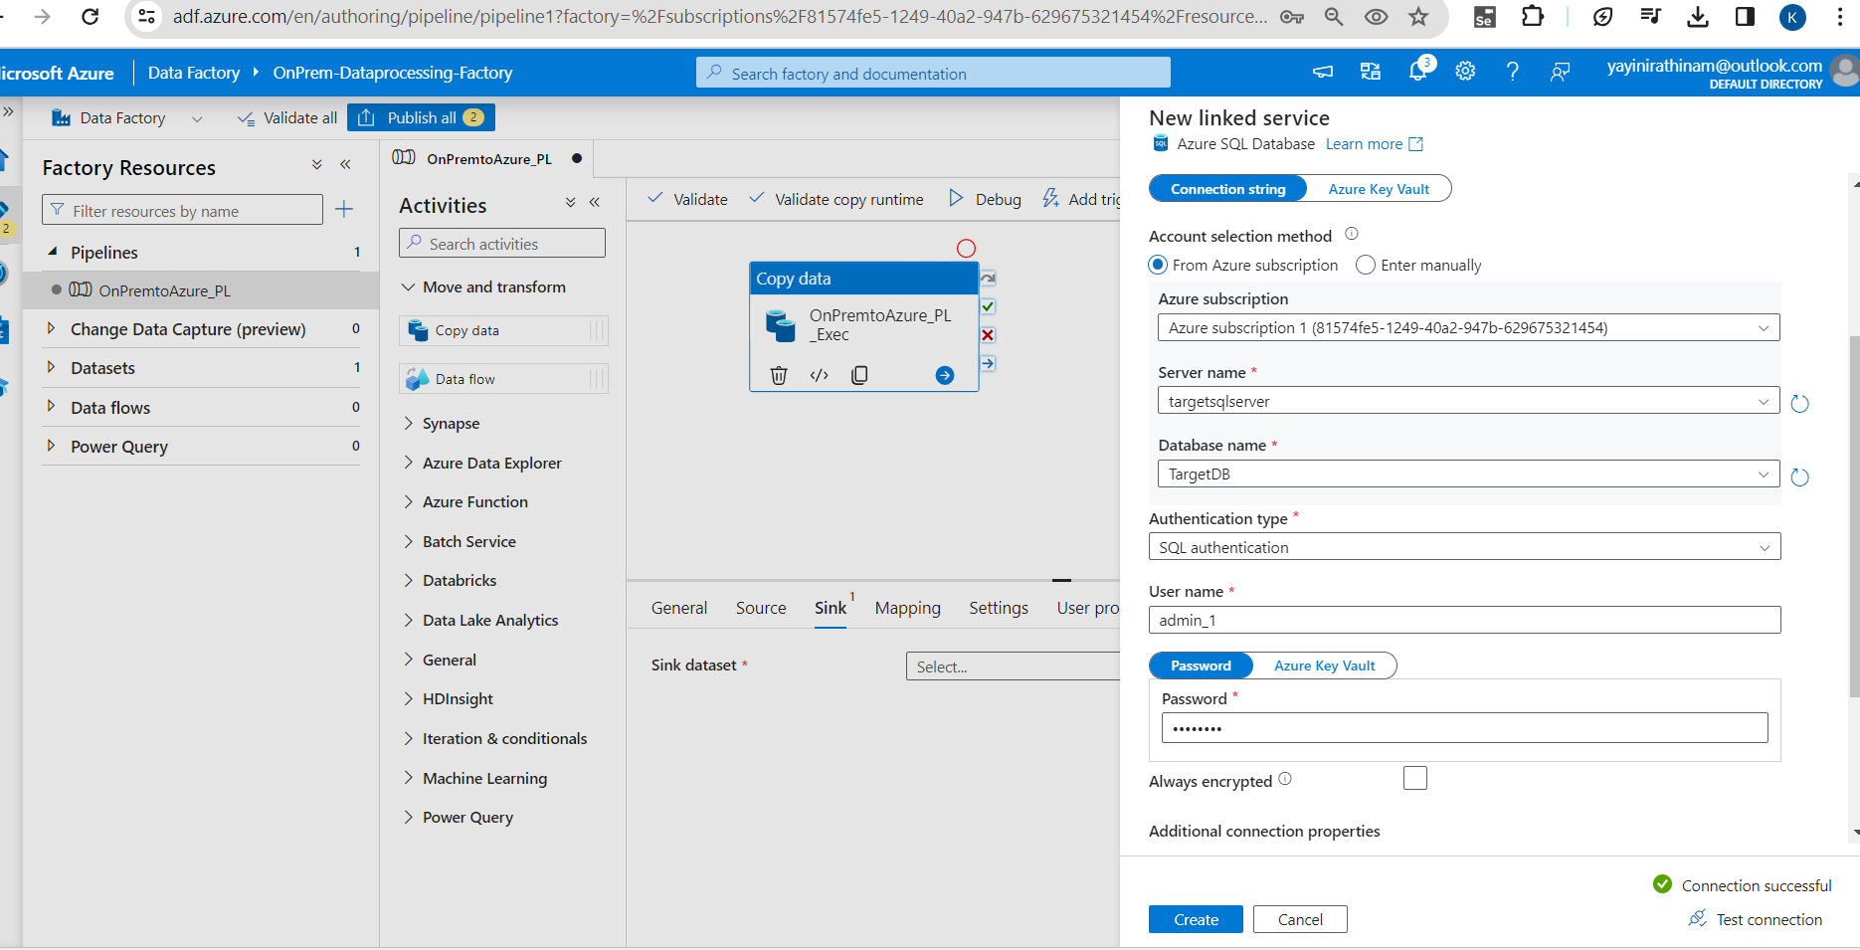

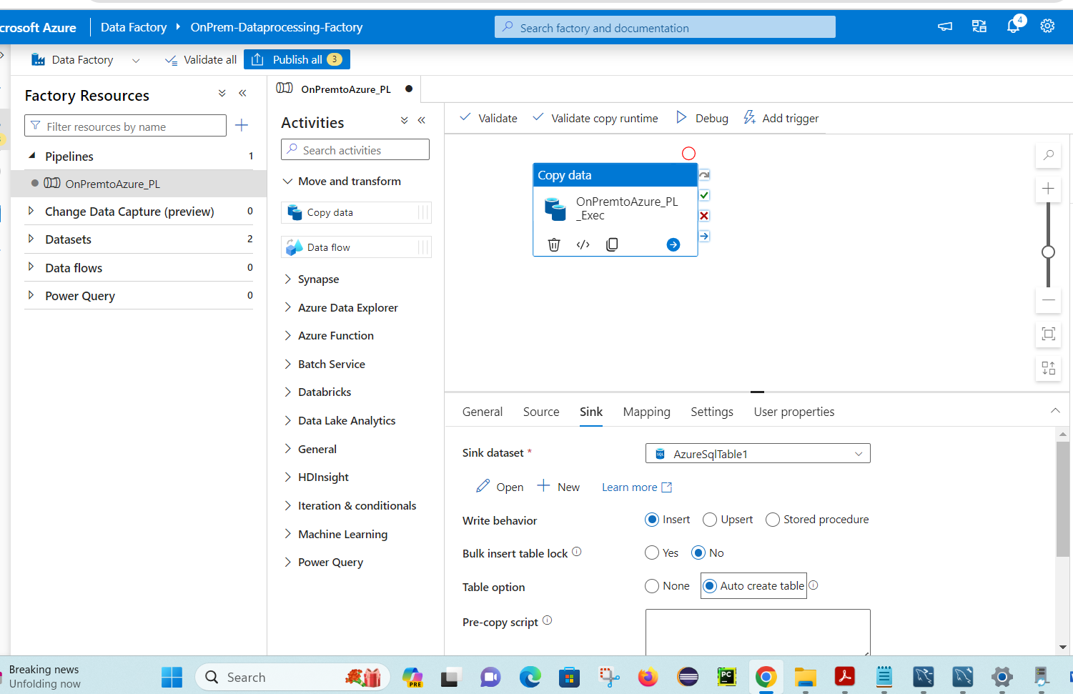

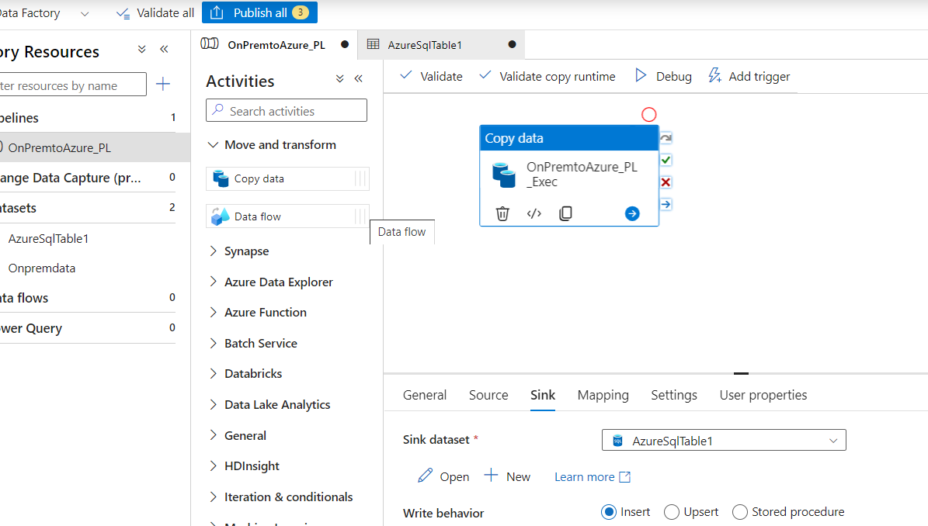

Datasets will de displayed automatically

